NYSCA Logo - Black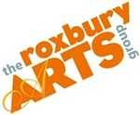

**Roxbury Arts Group**

PO Box 93

5025 Vega Mountain Road

Roxbury NY 12474

607.326.7908

www.roxburyartsgroup.org

Ursula Hudak, Creative Opportunities Coordinator, community@roxburyartsgroup.org

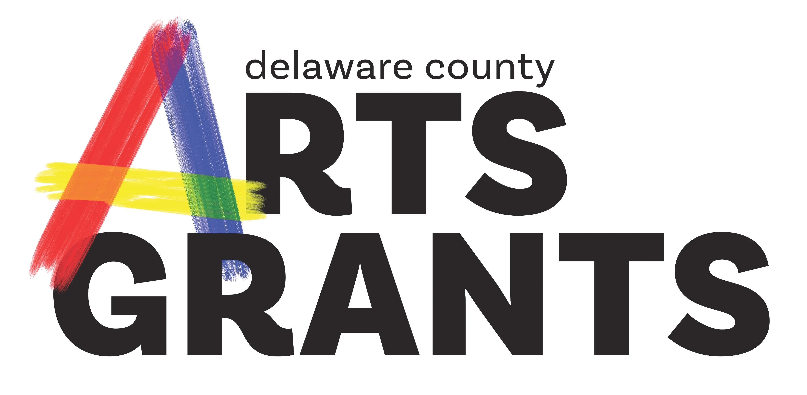

**Delaware County Arts Grant Guidelines**

A program of the Roxbury Arts Group made possible with funds from the Statewide Community Regrants Program of the New York State Council on the Arts (NYSCA)

**COMPLETE GUIDELINES FOR 2024**

**Grant Deadline: 4 pm on Thursday, January 11th, 2024**

If there are any accommodations that the Roxbury Arts Group can provide to facilitate your participation in the Delaware County Arts Grants program, please contact Ursula Hudak by calling call 607.326.7908 or e-mail to [community@roxburyartsgroup.org](mailto:community@roxburyartsgroup.org)

**Table of Contents**

1. **Overview**

a. Goals of the Delaware County Arts Grant Program

b. Under-Served Communities

c. Funding Expenditure

d. Funding Priorities for 2024

1. **Types of Grants and Eligibility**
   1. Community Arts Grants
   2. Community Arts Grants Eligibility
   3. Creative Learning
   4. Creative Learning Grant Eligibility
   5. Individual Artist
   6. Individual Artist Grant Eligibility
2. **Eligibility Limitations**

a. Repeat Applicants

b. Ineligible Projects or Expenditures

c. Eligible Organizations

d. Demonstrating Eligible Non-Profit Status

e. Use of a NYSCA Funded Site

f. Your Program and the American Disabilities Act (ADA)

1. **Fiscal Sponsorship/Partnerships**
   1. Do I need a Fiscal Sponsor or can I apply directly?
   2. What is a Fiscal Sponsor?
   3. What is a Community Based Partner?
   4. Individual Artists and Fiscal Sponsorship
2. **How to Apply**

a. Application Deadline

b. Where to Get an Application

c. Drafts Deadline

d. Information Sessions

e. Budget and Matching Funding

f. Optional Documents highly recommended:

g. Required Documents

1. **Decision Making**

a. Grant Decisions

b. Panel Criteria

1. **After Decision**

a. Award Notification

b. Grantee Responsibilities

c Other Documentation During and After Projects

d. Appeals

### Overview

The Statewide Community Regrant program (SCR), known in Delaware County as the Delaware County Arts Grant, is a re-grant program of the New York State Council on the Arts (NYSCA). Founded in 1977, SCR was developed to ensure that New York State's cultural funding reaches every part of the state. The SCR grant program has since become one of the Council's most effective means of making arts support available to geographically, economically, and ethnically diverse segments of the state's population. The SCR program is administered by the Roxbury Arts Group in Delaware County and these grants are made possible with funds from the Office of the Governor and the New York State Legislature.

The Delaware County Arts Grant offers three distinct funding categories: Community Arts, Creative Learning, and Individual Artist**.**A single applicant is able to submit up to **three (3)** project requests in any combination of the three grant categories, but the requested funding amount of the combined projects may total no more than $5,000.

**a. Goals of the Delaware County Arts Grant** **Program**

* Making quality arts programming available to all Delaware County residents and visitors
* Assisting emerging arts organizations
* Supporting the artistic expression of Delaware County’s diverse cultural groups
* Making arts programming accessible to under-served and minority communities

**b. Under-Served Communities**

Under-served communities are comprised of individuals who have limited access to art programs, services or resources and may be marginalized due to geography, race, economic status, gender, gender identity, sexual orientation, age, religion or disability or other demonstrable factors. The term "community" can refer to a group of people with a common heritage or characteristics, whether or not living in the same place. Age alone (i.e. youth, seniors) does not qualify a group as being under-served.

**c. Funding Expenditure**

The Delaware County Arts Grant funds are intended to assist with:

* Activities/Projects of local arts organizations including both live and virtual activities.
* Artist fees
* Marketing/publicity costs
* Direct administrative expenses and/or planning and preparation expenses for a proposed event.
* Supplies and materials needed to execute the proposed project. Individual items may not exceed $1,000. Examples: art supplies, sheet music, hardware, memory cards, and other consumable equipment.
* Equipment, software, subscriptions, and training needed to execute the proposed project. Individual items may not exceed $1,000. Examples: cameras, lighting equipment, subscriptions, and training tools.

**d. Funding Priorities for 2024**

Each year the Delaware County Arts Grant creates funding priorities based on the needs of the community. Applicants can and should justify in their application how their project is appliable to one or more of funding priority as listed below. The funding priorities this year are:

* Projects that result in public art. They may be temporary or permanent.
* Projects that incorporate media arts
* Projects that incorporate fiber arts, pottery, glassblowing and metal smithing
* Projects that incorporate folk/traditional arts
* In-School/After School Creative Learning Projects.
* Creative Placemaking: Creative placemaking animates public and spaces, rejuvenates structures and streetscapes, improves local business viability and public safety, and brings diverse people together to celebrate, inspire, and be inspired.
* New, emerging and grass-roots organizations and artists.

### Types of Grants and Eligibility

**a. Community Arts Grants** constitute the majority of Delaware County Arts Grant activity. These grants provide support for arts and cultural projects to community-based organizations, groups, collectives or artists. These projects are community-based arts activities offered to the public and should be open and accessible to all. This may include but are not limited to: exhibitions, workshops, performances (all disciplines), festivals, screenings or readings. Community Arts Grant support enables emerging artists and organizations to grow professionally and to enhance the cultural climate in communities where they live and operate. Funding of up to $5,000 is available to be applied to a maximum of 90% of project costs.

**b. Community Arts Grants Eligibility**

To apply for Community Arts Grants organizations and artists applicants must meet the following criteria:

* An organization or artist must send a representative to attend an Information Session or meet one-on-one with a member of the Roxbury Arts Group staff.
* Individual artists and non-incorporated organizations that do not have 501c3 status may apply through the sponsorship of an eligible Delaware County-based, non-profit organization meeting the criteria of a fiscal sponsor or may apply directly as Community Based Partners.
* Non-profit organizations in Delaware County with 501c3 status may apply directly and sponsor their own project.
* Previously funded organizations/artists must have provided final reports if their program is completed.
* Organizations must not have applied directly, including those that were fiscally sponsored, to the New York State Council on the Arts (NYSCA) for funding in 2023 for projects in 202~~4~~, regardless of funding status.
* Projects cannot involve *partners* that apply directly to NYSCA.
* Delaware County Arts Grant site staff or Board Members cannot be involved (Delaware County Arts Grant site and Board Members may assist in projects but not lead them).
* Public school districts and their components cannot directly.
* Must not be private and/or religious affiliated schools.
* Must not be four and two year universities and colleges or their supporting foundations.
* Must not be New York State agencies (including SUNY schools) and departments and county government agencies and departments.
* Non-incorporated chapters of organizations whose “parent” is incorporated outside the Delaware County Arts Grant Service area cannot apply.

**************************************

**c.** **Creative Learning Grants** serve to bring teaching artists and their classroom skills into dedicated learning environments for all ages. Creative Learning projects must focus on the exploration of art and the artistic process. Funding of up to $5,000 is available to be applied to a maximum of 90% of project costs.

**In-School Project** grants support the role that local cultural organizations and/or individual artists (working in partnership with a public school play in engaging K-12 public school students in rich artistic learning experiences during school hours. Inter-curricular collaboration is encouraged but not required. **After-School Learning** grants support Creative Learning projects that take place after-school. Projects can physically be held on or off school grounds. An example of a suitable off school site would be a public library. **Community-Based Learning** grants support Creative Learning projects that take place in community-based settings for youth and/or learners of all ages and abilities. These workshops can be exclusive to particular groups and programs such as Youth Groups and Seniors Homes.

Regardless of which Creative Learning option you choose, projects must provide:

* Sequential, skills-based study that incorporates one or more art forms and includes a minimum of 3 sequential hands-on learning sessions
* In-depth, age and skills appropriate learning opportunities
* Hands-on, participatory creation and/or learning opportunities in one or more art forms that may culminate in exhibitions, productions, or demonstrations
* Stated learning goals, methodologies and outcomes and a means for evaluation

**d. Creative Learning Grant Eligibility**

School partners cannot apply directly for Creative Learning Grant funds. Applications for Creative Learning Grants must be submitted by teaching artists, Community Based Partners or Fiscal Sponsors*.*

* Applicant must be based in Delaware County
* Lead teaching artist must be 18 years of age or older at the time of application.
* Community Based Partners and/or Fiscal Sponsors must be located in Delaware County.
* If Fiscally Sponsored by an organization that is not the Roxbury Arts Group, Fiscal Sponsors must meet Fiscal Sponsor Guidelines.
* All projects, organizations, Fiscal Sponsors and teaching artists must conduct all activities in a way that does not discriminate on the basis of race, color, national origin, religious belief, gender, gender identity, sexual orientation or disability.
* A letter of commitment from the partner school and the artist or organization must be included with the application to be eligible for funding. The letter of commitment must outline in detail the partner(s) support of the project (monetarily and otherwise) and anticipated roles and responsibilities for each partner involved. The partnership letter should be on the partner(s) letterhead and signed by the principal of the partner school and director of the partner organization.

**************************************

**e. Individual Artist Grants** offer commissioning support to individual artists in the amount of $2500 per commission for the creation of a new work in a community setting, with no match required. This grant opportunity represents a “live & work” investment in local artists. It is designed to increase support for local artist-initiated activity and to highlight the role of artists as important members of our community.

An essential element of this funding is that the artist engage the community in either the presentation of their work ***and/or*** the inclusion of the community in the development of the new work either or in reflection/topic.

**f. Individual Artist Grant Eligibility**

Individual artists may apply directly for this category if they meet the following conditions:

* Individual artist applicants **MUST** be current NYS residents and must be a resident of Delaware County. Proof of residency is required. All documents must contain the individual’s name, address, and documentation must be dated within the previous year.
* Individual Artist applicants must be 18 years of age or older and may not be enrolled in a full-time degree program.
* Have met with the Roxbury Arts Group to discuss their project.

### Eligibility Limitations

**a. Repeat Applicants**

If you have received funding in the past, you are eligible to apply again. However, prior funding does not guarantee continued support. Each application is reviewed in the context of the current program guidelines, stated funding priorities, and evaluative criteria. The review panel will also consider compliance with the previous contract and reporting requirements. Past grantees that have failed to submit final reports are ineligible to apply.

**b.** **Ineligible Projects, Expenditures and Applicants**

* Programs taking place outside of Delaware County
* Projects that cannot be completed by December 31, 2024
* Projects where the arts are not the driving force and focus of a project.
* Organizations and artists that have applied directly to NYSCA in the most recent cycle
* Past grantees that have failed to submit final reports
* Individuals without an eligible sponsor or community partner organization (**Exception: Individual Artist category**)
* Projects not open to the general public or activities restricted to an organization’s membership (camps, membership, and kids clubs, college associations, etc.) **Exception: Creative Learning Grant.**
* Events that take place in private homes (unless open to the public and accessible to all)
* Requests greater than an applicant's project expenses minus total project income.
* Operating expenses of privately-owned facilities (e.g. homes and studios).
* Acquisition of works of art.
* Contingency funds.
* The purchase of permanent equipment that exceeds $1,000 or capital improvements.
* Creation of textbooks or classroom material.
* Lobbying expenses.
* Regrants by applicants to fund other activities.
* Cash prizes, juried shows, fellowships, educational scholarships or other awards to students.
* Fees paid to children under the age of 18.

**c. Eligible Organizations**

Non-profit organizations applying directly **MUST** fulfill **ALL** of the following conditions:

* A 501(c)(3) or New York State non-profit organization.
* The legal address of the non-profit organization must be located in Delaware County.
* Have a board of directors or a governing body that meets to determine and review policy.
* Conduct all activities in a way that does not discriminate on the basis of race, color, national origin, religious belief, gender, gender identity, sexual orientation or disability.
* Applicants/artists must be at least 21 years of age at the time of application.

**d. Demonstrating Eligible Non-Profit Status**

Your organization must submit **ONE** of the following documents that applies to your organization:

* Letter of Determination from the IRS indicating tax exempt status under section 501c3
* Documentation of charter by NY State Board of Regents under section 216 of the NY State Education Law
* Documentation of Incorporation under Section 402 of the NY State Not-for-Profit Corporation Law
* Current NY State Bureau of Charities (Office of the Attorney General) filing receipt
* Official authorization as an arm of local government (i.e., a formal letter on official stationery signed by the appropriate county, city, town or village executive)

Other Eligible Organizations and Artists

* Individual artists, groups or collectives, and unincorporated entities who are working with an eligible fiscal sponsor or community-based partner.
* A government, quasi-governmental entity, or tribal organization.

**All grant categories require a partnership with a non-profit organization either as a non-profit applying directly, through an applicant chosen non-profit Fiscal Sponsor, or as a Community Partner enrolled in the Roxbury Arts Group Fiscal Sponsorship Program.**

**e. Use of a NYSCA-funded Site**

A direct NYSCA grantee may offer their venue gratis to a Delaware County Arts Grant -funded project. The Delaware County Arts Grant Grantee may pay for any direct costs related to use of the venue such as custodial, security and contracted technical personnel or venue personnel however:

* The Delaware County Arts Grant Grantee must make all attempts to handle box office tickets. If this is not possible, a NYSCA site may offer their box office ticketing but must not impose any additional service fees, facility fees or any other costs to the tickets. If a Delaware County Arts Grant project uses a NYSCA site for ticketing the NYSCA site should create a full box office accounting and itemized report at the conclusion of the event and should present this to the Delaware County Arts Grant Grantee. This should be kept on file in case it is requested by the Roxbury Arts Group.
* The direct NYSCA grantee must not profit from the Delaware County Arts Grant program (i.e. ticket sales, donations, etc.)
* The direct NYSCA site may display the project on the website and other materials but must clearly not be advertised as part of the NYSCA grantee’s season/programming. The use of the crediting verbiage, found in successful applicant’s contracts, and the use of the Roxbury Arts Group must be used on promotional materials and webpages.

**f. Your Program and the American Disabilities Act (ADA)**

* Presentations of funded projects must take place in venues that comply with ADA Section 504 regulations insuring accessibility for people with disabilities. You may call the ADA Hotline (1-800-514-0301 – 800-514-0383 TTY – www.ada.gov) for more information.

### Fiscal Sponsorship/Partnerships

* 1. **Do I need a Fiscal Sponsor or can I apply directly?**

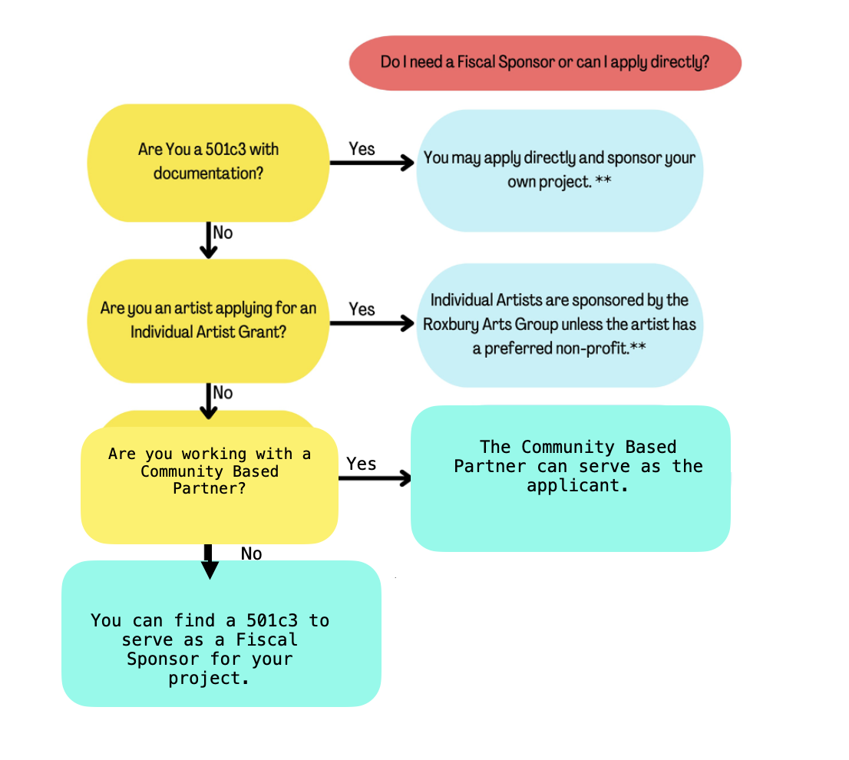

* 1. **What is a Community Based Partner?**

A “*partner”* is defined as any entity that assists in the creation, development or delivery of a project.

Organizations or Individual Artists can apply directly for SCR funds with Community Based Partners in the Community Arts Category or the Creative Learning Grant. Organizations must detail and select a single member who will receive funds and must include this individuals Social Security in the W9 provided in their application. Awards CANNOT be paid to businesses.

* The Community Partner must be based in Delaware County.
* You are limited to three requests in any combination of categories totaling no more than $5000, Community Based Partner applicants count towards this funding limit.
* Direct NYSCA applicants may not apply for the Delaware County Arts Grant applicant.
* Community Based Partners will handle receiving their own award from the Roxbury Arts Group.
* Community Based Partners should manage all IRS required reporting including the creation and distribution of 1099 or W9 forms where applicable.
* Community Based Partners are responsible for all grant reporting requirements including applications, change of scopes and final reports.
* A letter from the Community Based Organization acknowledging the applicant as part of the organization is required and should be on the organizations Letter Head and be signed by an organizations board member.
* Must be based in Delaware County.
  1. **What is a Fiscal Sponsor?**

An individual artist or collective that has no 501c3 status may apply for a Delaware County Arts Grant through an applicant chosen fiscal sponsor. Organizations that are non-profits may apply directly and serve as their own Fiscal Sponsor. The entity serving as the fiscal sponsor must meet the same eligibility requirements as an applicant organization listed above*.* Awards are sent to the address of the Fiscal Sponsor on the W9 provided.

* The fiscal sponsor must be based in Delaware County; however, the sponsored applicant is not required to reside in that county.
* A direct Delaware County Arts Grant applicant may also serve as a fiscal sponsor. Serving as a fiscal sponsor, those requests do not count towards the three-request limit or $5000 maximum.
* The sponsored applicant is limited to three requests in any combination of categories totaling no more than $5000.
* Direct NYSCA applicants may not serve as a fiscal sponsor for a Delaware County Arts Grant applicant.
* A letter of Agreement is required detailing roles, responsibilities and commitment from the Fiscal Sponsor. The Letter must also name the applicant and give permission for them to apply, this includes staff members applying directly on behalf of non-profits and applicants applying under Fiscal Sponsor guidance.
* Fiscal sponsors will handle receiving the award from the Roxbury Arts Group. Further finance arrangements should be made between the fiscal sponsor and the applicant. This should be laid out in the Letter of Agreement between parties.
* Fiscal sponsors are responsible for all IRS required reporting including the creation and distribution of 1099 forms where applicable.
* Fiscal sponsors are responsible for all grant reporting requirements including applications, change of scopes and final reports.
* Fiscal Sponsors are expected to assist applicants in the completion of their application, budget, projects and remain aware of project changes.
* Submit a list of their board of directors, mission statement, and a financial statement.
  1. **Individual Artists and Fiscal Sponsorship**

Typically artists applying under the Individual Artist category are Fiscally Sponsored by the Roxbury Arts. However if artists have a non-profit they would prefer to work they are allowed to do so. Artists looking for Fiscal Sponsorship by the Roxbury Arts Group must arrange for a meet and greet to discuss their project and the roles and responsibilities expected. A Letter of Commitment will be drafted between the artists and RAG to reflect this and should be attached to your application.

### How to Apply

**a. Application Deadline**

**Applications must be submitted via the Roxbury Arts Group website no later than 4 pm ON Thursday, January 11th, 2024.** Early submissions are encouraged. Applications received after the deadline will not be accepted. Incomplete, handwritten or ineligible applications will not be considered.

**b. Where to get an application**

A link to the application is available at the Roxbury Arts Group website at [www.roxburyartsgroup.org](http://www.roxburyartsgroup.org) under the Opportunities menu. Guidelines and a link to the applications can also be emailed to you upon request.

**c. Drafts Deadline**

If you wish to have the Roxbury Arts Group staff review a draft of your request, you may schedule a meeting either in person or by phone. Reviewing an applicant’s draft proposal is for the purpose of providing technical assistance and does not guarantee that it will receive funding. Drafts must be submitted prior to meeting with Roxbury Arts Group staff. The earliest you may submit a draft for review is **Tuesday, December 5th, 2023. Draft reviews close January 2nd, 2024.**

1. **Information Sessions**

All applicants, even those that have received funding in the past, **MUST** meet either in person, digitally or by phone with Roxbury Arts Group staff to discuss your project. An in-depth review of the guidelines and application will be presented at a series of Grant Information Sessions. The individual responsible for completing the grant application is encouraged to attend. Applicants who are unable to attend a meeting may request a meeting with the Creative Opportunities Coordinator.

Grant Information Sessions have been scheduled at the following dates and times:

**In Person Sessions:**

Wednesday, November 8, 2023, 5:30pm, William B Ogden Free Library, 42 Gardiner Place, Walton, NY, 13856

Thursday, November 9, 2023, 6pm, The Camptons Gallery, 158 East Front Street, Hancock, NY, 13783

Saturday, November 11, 2023, 2pm, Roxbury Arts Group, 5025 Vega Mountain Road, Roxbury, NY, 12474

Thursday, November 16, 2023, 2pm, Headwaters Arts Center, 66 Main Street Stamford, NY, 12167

Tuesday, November 21, 2023, 6pm, Sidney Memorial Library, 8 River Street, Sidney, NY, 13838

**Online Sessions:**

Saturday, October 28, 2023, 2pm, Zoom

Wednesday, November 1, 2023, 2pm, Zoom

Friday, November 3, 2023, 5pm, Zoom - **Individual Artist Session**

Tuesday, November 14, 2023, 6:30, Zoom

* 1. **Budget and Matching Funding**

Applications must include information on how grant funds will be spent, preferably in a spreadsheet. The budget breakdown must include the grant request amount and how funds will be spent. The Delaware County Arts Grant is not intended to cover the complete cost of the proposed project. **10%** of the proposed project income must come from other funding sources. This can include planned in-kind contributions (non-monetary), cash contributions, cash income, or a combination of both. **Your project budget must demonstrate that a minimum of 10% of your funding must be matching funds or in-kind donations***.* You may apply for a maximum of 90% of the total cost of your proposed project for the Community Arts Grant and Creative Learning Grants. No match is required for Individual Artist Grants.

**The address on the application MUST BE A DELAWARE COUNTY ADDRESS - NO EXCEPTIONS.**

**NOTE:** A New York State Tax Exemption Certificate from the Department of Taxation and Finance is NOT considered proof of non-profit status and should not be submitted.

* 1. **Optional Documents highly recommended:**
* Work samples.
* Artist Bio’s.
* Artist Statements.
* Links to video clips of performances.
* Previous promotional materials if a recurring project.
* Feedback from Audience/Participants of annual projects.
* Photography, Articles, videos etc of previous events.

**g. Required Documents:**

Your application will not be accepted without the required documents. The chart below details all required materials over all applications. Documents with a * are needed for your application:

|  |  |  |
| --- | --- | --- |
| IA (Individual Artist) | CA (Community Arts) | CL (Creative Learning) |

|  |  |  |  |  |  |  |
| --- | --- | --- | --- | --- | --- | --- |
|  | Artist IA Grants w/ RAG Fiscal Sponsorship | Fiscally Sponsored CA Grants | Fiscally Sponsored CL Outside Schools | Community Based Non Profits CA/CL Outside Schools | Community Based Non-profits Partner CL In-schools | Artists CL Inside Schools |
| W-9 signed/dated in the current year | * with SSN | * | * | * with EIN Number | * with EIN Number | * |
| Proof of Residency  telephone bill, NY State Driver’s License or ID Card, or Voter Registration Card. | * |  |  |  |  |  |
| Fiscal Sponsor or Community Partner Agreement,  on the partner(s) letterhead, signed by the director of the partner org, detailing roles between parties | * | * | * |  | * |  |
| Letter of Commitment from School,  on the partner(s) letterhead, signed by the director of the partner org, detailing roles between parties |  |  | * | * | * | * |
| List of Board Members |  | * | * | * | * |  |
| Proof of Non-Profit Status |  | * | * | * | * |  |
| Non-Profit Mission Statement |  | * | * | * | * |  |
| Recent Financial Report of Non-Profit |  | * | * | * | * |  |
| Letter of Responsibility for Permanent Equipment, if applicable,  signed by the Non-Profit board president |  | * | * | * | * |  |
| Budget | * | * | * | * | * | * |
| Letter Acknowledging Applicant as a member of staff - on the org. Letter Head, signed by an org. board member |  |  |  | * | * |  |
| Letter of agreement from RAG | * |  |  |  |  | * |
| Fiscal Sponsorship Agreement between applicant and Fiscal Sponsor |  | * | * |  |  |  |

### Decision Making

**a. Grant Decisions**

Applications are reviewed for eligibility, completeness, and accuracy by Roxbury Arts Group staff. It is your responsibility to submit a complete and accurate application. As part of the review process, Roxbury Arts Group staff may contact you by telephone or e-mail to clarify and review information.

A panel of artists, arts administrators, community leaders, and community members approved by the Delaware County Arts Grant Advisory Panel and appointed by the Roxbury Arts Group Board of Directors, evaluates each application and recommends a level of funding based on the evaluation criteria, the funding priorities and the grant guidelines. Upon request, Panelists will be furnished with final reports as well as audit information, prior panel comments and correspondence when considering organizations/individuals who have applied or been funded in prior years. The Panel's recommendations are reviewed by the Roxbury Arts Group’s Board of Directors, which has the final authority for all decisions. The Roxbury Arts Group staff has no vote in the decisions made.

**b. Panel Criteria**

Awards are based on a competitive review process. Each application is reviewed on the basis of its own merits and against others in the application pool. The panel will make funding recommendations based primarily on the following criteria:

* The artistic merit and quality of proposed project is priority over all panel considerations.
* Community benefit, service to a broad, unique or under-served constituency - demonstrated need for the project (community support and interest in the project)
* Appropriate budget for the project
* Clarity of goals and demonstrated ability to achieve them
* Adherence to the grant guidelines and funding priorities
* Clearly defined plan for the implementation and management of the program

### After Decision

**a. Award Notification**

The Roxbury Arts Group notifies all applicants, by email, regarding the status of their application after Board approval. This usually occurs by the end of February and contracts will be mailed to awarded artists/organizations shortly thereafter. Projects sponsored by a Fiscal Sponsor will have checks mailed to the sponsoring organization, otherwise checks will be mailed out to Individual Artists or funded organizations. Funds will only be disbursed after all documentation is accounted for including a signed contract. Checks will only be mailed out to Delaware County addresses detailed on the supplied W-9 NO EXCEPTIONS.

**b. Grantee Responsibilities**

* Sign and adhere to the terms of a Project Contract and a Publicity Agreement which includes crediting both the Roxbury Arts Group and NYSCA for funding on all materials according to language used in the project contract as well as including the Roxbury Arts Group logo (not NYSCA’s) on all printed materials relative to your funded project;
* Attend and participate in the Delaware County Arts Grant awards ceremony;
* File reports as identified in the project contract;
* Provide copies of publications and promotional materials related to the funded project;
* Provide Roxbury Arts Group with an advance schedule of funded events;
* Provide four complimentary tickets for Roxbury Arts Group auditors; and
* Notify the Roxbury Arts Group in a timely fashion, of any changes to your project including dates, times and places where events are to be held.

**c. Other documentation during and After Projects**

* If a directly funded NYSCA organization is hosting/handling a Delaware County Arts Grant projects Box office, see use of NYSCA site, page 6, for required reporting that should be made available on request of the Roxbury Arts Group at the completion of the project.
* On completion of all Delaware County Arts Grant projects a final report should be submitted to the Roxbury Arts Group within 30 days of the final event date or before December 31st 2024. Past grantees that have failed to submit final reports are ineligible to apply for future funding.
* Should changes be made to projects after funding has been awarded, a Change of Scope should be completed and returned to the Roxbury Arts Group as soon as possible. This includes changes made ~~i~~f partial funding is awarded.

**d. Appeals**

An appeals process is in place for applicants who are denied funding and can demonstrate that information was withheld and/or misrepresented, and/or that an improper procedure occurred. ***Dissatisfaction of the Panel’s decision or funding level is not grounds for appeal***. Applicants denied funding will be furnished with the entire Appeals Process and Procedures when notified in writing of the Board's determination.

**QUESTIONS:**

**Contact Ursula Hudak, Creative Opportunities Coordinator, at 607.326.7908 or by email at community@roxburyartsgroup.org.**