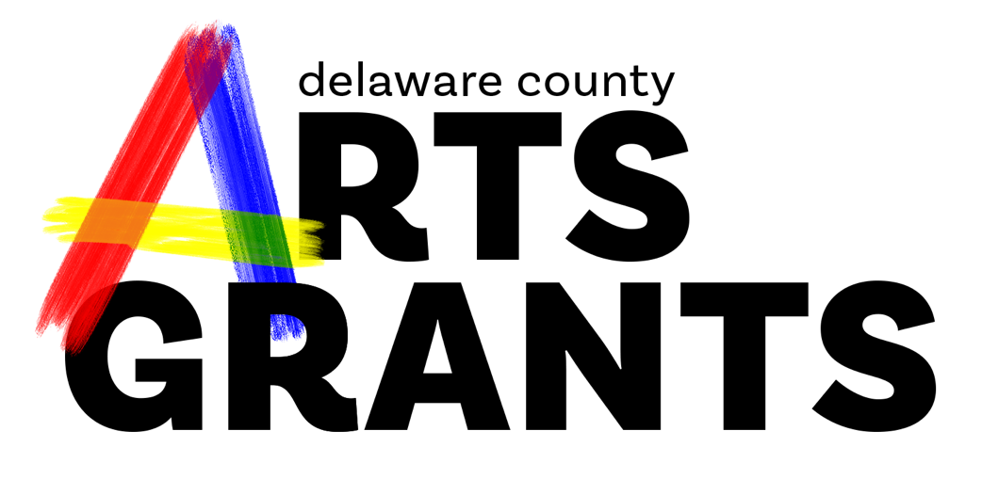
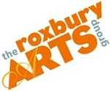
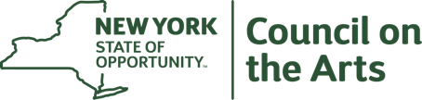

Delaware County Arts Grants
A regrant program of the New York State Council on the Arts with the support from the office of the Governor and the New York State Legislature and administered in Delaware County
by The Roxbury Arts Group

Final Report Form for Fiscal Year 2024
Please return this FINAL REPORT form no later than 30 days after the end of your program, or by December 31, 2024, whichever comes first.

Grant Received:
Organization or Artist:
Person preparing report: Phone
e-mail
Sponsored Artist (if applicable) Phone
e-mail

- Briefly describe the project or program carried out with this award.

2. Does this differ significantly from that indicated in your application? (Artists, no. of performances, location, etc.) If yes, elaborate.

3. For individual artists: Did this project assist you in moving forward with your career? If so, please elaborate briefly.

4. Please list the dates, names, and locations for your program. Use a second page if needed.

5. Number of people served by this program:

Youth: Participating Artists:
Volunteers: Other Individuals:

6. What did these funds provide that would not have been possible for your organization without such aid?

7. How can the DEC Program be improved to serve you better in funding year 2025. Use a second page if needed.

Include a copy of each promotional piece. If at all possible, send a good photo that we may use to seek Statewide Community Regrant Funds for year 2024.

Signature of Chief Financial Officer

Please return this form and corresponding budget to:

Ursula Hudak
Creative Opportunities Coordinator
PO Box 93
Roxbury, NY 12474
607-326-7908
community@roxburyartsgroup.org

