NYSCA Logo - Black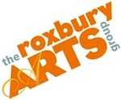

**Roxbury Arts Group**

PO Box 93

5025 Vega Mountain Road

Roxbury NY 12474

607.326.7908

www.roxburyartsgroup.org

Samantha Nick, Grants & Community Coordinator, community@roxburyartsgroup.org

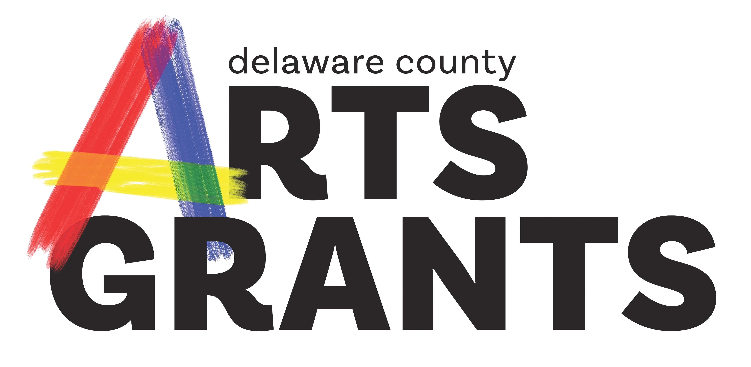

**Delaware County Arts Grant Guidelines**

A program of the Roxbury Arts Group made possible with funds from the Statewide Community Regrants Program of the New York State Council on the Arts (NYSCA)

**COMPLETE GUIDELINES FOR 2023 (FY22)**

**Grant Applications must be submitted via Submittable to the**

**Roxbury Arts Group by 4 pm on Thursday, November 17, 2022**

If there are any accommodations that the Roxbury Arts Group can provide to facilitate your participation in the Delaware County Arts Grants program, please contact Samantha Nick by calling call 607.326.7908 or e-mail to [community@roxburyartsgroup.org](mailto:community@roxburyartsgroup.org)

**Table of Contents**

1. **Overview**

a. Limits

b. Funding and Matches

c. Funding Expenditure

1. **Types of Grants**

a. Community Arts Grants

b. Creative Learning

c. Individual Artist

d. Funding Priorities for 2023

e. Low Priority Projects

1. **Eligibility**

a. Repeat Applicants

c. Ineligible Projects or Expenditures

d. Goals of the Delaware County Arts Grant Program

e. Under-Served Communities

f. Your Program and the American Disabilities Act (ADA)

g. Eligible Organizations and Fiscal Sponsors

h. Demonstrating Eligible Non-Profit Status

i. Community Arts Grants Eligibility

j. Creative Learning Grant Eligibility

k. Individual Artist Grant Eligibility

1. **Direct NYSCA Funded Sites**

a. Partners

b. Use of a NYSCA Site

1. **Fiscal Sponsorship/Community Based Partnership**

a. Do I need a Fiscal Sponsor or can I apply directly?

b. What is a Fiscal Sponsor?

c.What is a Community Based Non-Profit Partner?

d. Individual Artists and Fiscal Sponsorship

1. **COVID 19 New Guidelines**

a. COVID 19 Guideline Changes

b. Effects of FY20 Changes (Due to COVID 19) on FY21 Applications

1. **Information Sessions**
2. **How to Apply**

a. Application Deadline

b. Where to Get an Application

c. Drafts Deadline

d. Additional Materials and Work Samples Required

e. Other Documentation During and After Projects

f. Matching Funds

1. **Decision Making**

a. Grant Decisions

b. Panel Criteria

1. **Successful Applicants**

a. Award Notification

b. Grantee Responsibilities

1. **Appeals**
2. **Application Deadline**

### Overview 1.

The Delaware County Arts Grant, formally known as the Statewide Community Regrants Grant Program, is a re-grant program of the Roxbury Arts Group. These grants are made possible with funds from the Statewide Community Regrants (SCR) program of the New York State Council on the Arts (NYSCA) and is supported by the Office of the Governor and the New York State Legislature.

Founded in 1977, the Statewide Community Regrants Program (SCR) was developed to ensure that New York State's cultural funding reaches every part of the state. The SCR Grant Program has since become one of the Council's most effective means of making arts support available to geographically, economically, and ethnically diverse segments of the state's population. The SCR Grant Program, known as The Delaware County Arts Grant in Delaware County, is administered by the Roxbury Arts Group.

**a. Limits**

A single applicant is able to submit up to **three (3)** project requests in any combination of the categories below, totaling no more than $5,000.

**b. Funding and Matches**

The Delaware County Arts Grant is not intended to cover the complete cost of the proposed project. The Delaware County Arts Grant is highly competitive with an average award of roughly $2225 and with 66% of applicants receiving some level of funding in FY21. You may apply for a maximum of 90% of the total cost of your proposed project for the Community Arts Grant and Creative Learning. 10% of your funding must be matching funds or in-kind donations *(See How to Apply 8. f. Matching Funds)*

**c. Funding Expenditure**

The Delaware County Arts Grant funds are intended to assist with:

* Activities/projects of local arts organizations and artists.
* Artist fees
* Marketing/publicity costs
* Direct administrative expenses
* Supplies and materials needed for the execution of the program

### Types of Grants 2.

The Delaware County Arts Grant serves as an umbrella for three distinct funding categories: Community Arts, Creative Learning, and Individual Artist Category**.**

**All categories require a partnership with a non-profit organization either as a non-profit applying directly, through an applicant chosen non-profit Fiscal Sponsor, or as a Community Partner enrolled in the Roxbury Arts Group Fiscal Sponsorship Program. *(See Fiscal Sponsorship/Community Based Partnership 5)***

**************************************

**a. Community Arts Grants** constitute the majority of Delaware County Arts Grant activity. These grants provide support for arts and cultural projects to community-based organizations, groups, collectives or artists. These projects are community-based arts activities offered to the public and should open and accessible to all, this may include but are not limited to: exhibitions, workshops, performances (all disciplines), festivals, screenings or readings. Community Arts Grant support enables emerging artists and organizations to grow professionally and to enhance the cultural climate in communities where they live and operate.

**Community Arts Grants** this may include but are not limited to: exhibitions, workshops, performances (all disciplines), festivals, screenings or readings.

**************************************

**b.** **Creative Learning** funds serve to bring teaching artists and their classroom skills into dedicated learning environments for all ages within three funding strands: **In-School Projects, After-School Learning, and**

**Community-Based Learning.**

**In-School Project** grants support the role that local cultural organizations and/or individual artists (working in partnership with a public school) play in engaging K-12 public school students in rich artistic learning experiences. Creative Learning projects must focus on the exploration of art and the artistic process. Inter-curricular collaboration is encouraged but not required.

**After-School Learning** grants support Creative Learning projects that take place in after-school settings engaging K-12 public school students. Emphasis is placed on the depth and quality of the creative process through which participants learn through or about the arts. Projects must focus on the exploration of art and the artistic process. Projects can physically be held on or off school grounds. An example of a suitable off school site would be a public library.

**Community-Based Learning** grants support Creative Learning projects that take place in community-based settings for youth and/or learners of all ages. These workshops can be exclusive to particular groups and programs such as Youth Groups and Seniors Homes. Emphasis is placed on the depth and quality of the creative process through which participants learn through or about the arts. Projects must focus on the exploration of art and the artistic process.

Regardless of which Creative Learning option you choose, projects must provide:

* Sequential, skills-based study that incorporates one or more art forms and includes a minimum of 3 sequential hands-on learning sessions
* In-depth, age and skills appropriate learning opportunities
* Hands-on, participatory creation and/or learning opportunities in one or more art forms that may culminate in exhibitions, productions, or demonstrations
* Stated learning goals, methodologies and outcomes and a means for evaluation

**************************************

**c. Individual Artist** grants offer commissioning support to individual professional artists in the amount of $2500 per commission for the creation of a new work in a community setting.

This grant opportunity represents a “live & work” investment in local artists. It is designed to increase support for local artist-initiated activity and to highlight the role of artists as important members of our community. These grants are intended to support creative artists interested in working within a community setting.

An essential element of this funding is the inclusion of the community in the artist’s project. The project must engage a segment of the community in either public program such as a gallery showing, artist talk or performance ***and/or*** the inclusion of the community through the development of the new work either directly in the process or in reflection/topic.

**d. Funding Priorities for 2023**

Each year the SCR grant creates funding priorities based on the needs of the community. This years are;

* In-School/After School Creative Learning Grants. Projects must include a partnership with a public school to be eligible for this funding priority.
* Creative Placemaking: Creative placemaking animates public and spaces, rejuvenates structures and streetscapes, improves local business viability and public safety, and brings diverse people together to celebrate, inspire, and be inspired.
* New, emerging and grass-roots organizations and artists.
* Projects that incorporate media arts
* Projects that incorporate photography.
* Projects that represent traditional arts.

**e. Low Priority Projects**

* Previously funded projects which don’t exhibit further growth, artistic expansion, community support and/or community need
* Projects that duplicate already existing and successful projects/services

### Eligibility 3.

**a. Repeat Applicants**

If you have received funding in the past, you are eligible to apply again. However, prior funding does not guarantee continued support. Each application is reviewed in the context of the current program guidelines, stated funding priorities noted above, and evaluative criteria. The review panel will also consider compliance with the previous contract and reporting requirements.

**c.** **Ineligible Projects or Expenditures**

A project must take place in Delaware County and be open to the general public (Exception: Creative Learning). The Delaware County Arts Grant program is unable to fund certain types of requests. The following types of projects and/or expenses are **NOT** eligible for funding:

* Programs taking place outside of Delaware County
* Projects that cannot be completed by December 31, 2023
* Projects where the Arts are not the driving force and focus of a project.
* Organizations and artists that have applied to NYSCA in the most recent cycle
* Past grantees that have failed to submit final reports
* Individuals without an eligible sponsor or partner organization (Exception: Individual Artist category)
* Projects not open to the general public or activities restricted to an organization’s membership (camps, membership, and kids clubs, college associations, etc.) Exception: Creative Learning Grant.
* Events that take place in private homes (unless open to the public and accessible to all)
* Programs in which the primary benefit is the financial gain by an individual/organization, requests greater than the project expenses, acquisitions of works of arts, capital expenditures/improvements, general operating support, including the operating expenses of private homes and studios. contingency funds and start-up or seed funding for the establishment of new organizations
* Rental or mortgage expenses that are part of the applicant / applicant organization’s or fiscal sponsor’s yearly budget are considered general operating support and therefore are an ineligible expenditure. Specific rental expenses related to hosting an SCR event can be covered by SCR funds or be included in matching funds as in-kind donations. *For example: An organization applying to do workshops within its own building cannot apply SCR funds towards the cost of their annual rent. However, if that same organization has expenses for renting a classroom outside of their organization then they could apply for funding with the SCR grant or be considered in-kind donations if the fee is waived for the program.*
* Cash prizes, Stipends or awards, trophies, contests/competitions and juried shows.
* Landscape and gardens (not including murals and other forms of permanent works of public art)
* Entertainment costs events such as theater parties, gallery openings. Non-arts related activities such as: Galas, benefits or fundraising events including entertainment costs for receptions, food or fundraising events -Entertainment such as: balloons, clowns, magicians. Fairs, parades, circus arts, martial arts, culinary arts, comedians, stand-up comics
* Lobbying expenses
* Re-grants by applicants to fund other activities
* Projects in which the main focus is at risk/social service, recreational, rehabilitative, or therapeutic, and/or liturgical in nature, even those containing an artist component.
* In-school (Exception: Creative Learning Grant) and home-school activities and programs, creation of textbooks or classroom material, fellowships or scholarships, projects where fees are paid to children or the use of children as professional artists
* Out of State travel costs.

**d. Goals of the Delaware County Arts Grant** **Program**

* Making quality arts programming available to all Delaware County residents and visitors
* Assisting emerging arts organizations
* Supporting the cultural expression of Delaware County’s ethnic groups
* Making arts programming accessible to under-served and minority communities

**e. Under-Served Communities**

Under-served communities are comprised of individuals who have limited access to art programs, services or resources and may be marginalized due to geography, race, economic status, gender, gender identity, sexual orientation, age, religion or disability or other demonstrable factors. The term "community" can refer to a group of people with a common heritage or characteristics, whether or not living in the same place. Age alone (i.e. youth, seniors) does not qualify a group as being under-served.

**f. Your Program and the American Disabilities Act (ADA)**

Presentations of funded projects must take place in venues that comply with ADA Section 504 regulations insuring accessibility for people with disabilities. You may call the ADA Hotline (1-800-514-0301 – 800-514-0383 TTY – www.ada.gov) for more information.

**g. Eligible Organizations and Fiscal Sponsors**

Non-profit organizations applying directly and Fiscal Sponsors *(See Fiscal Sponsorship/Community Based Partnership 5 for more information)* **MUST** fulfill **ALL** of the following conditions:

* A 501(c)(3) or New York State non-profit organization.
* The legal address of the non-profit organization must be located in Delaware County
* Have a board of directors or a governing body that meets to determine and review policy
* Conduct all activities in a way that does not discriminate on the basis of race, color, national origin, religious belief, gender, gender identity, sexual orientation or disability
* Applicants/artists must be at least 21 years of age at the time of application

**h. Demonstrating Eligible Non-Profit Status**

Your organization must submit **ONE** of the following documents that applies to your organization:

* Letter of Determination from the IRS indicating tax exempt status under section 501c3
* Documentation of charter by NY State Board of Regents under section 216 of the NY State Education Law
* Documentation of Incorporation under Section 402 of the NY State Not-for-Profit Corporation Law
* Current NY State Bureau of Charities (Office of the Attorney General) filing receipt
* Official authorization as an arm of local government (i.e., a formal letter on official stationery signed by the appropriate county, city, town or village executive)

**The address on the application MUST BE A DELAWARE COUNTY ADDRESS - NO EXCEPTIONS.**

**NOTE:** A New York State Tax Exemption Certificate from the Department of Taxation and Finance is NOT considered proof of non-profit status and should not be submitted.

**i. Community Arts Grants Eligibility**

To apply for Community Arts Grants organizations and artists applicants must meet the following:

* An organization or artist must send a representative to attend an Informational session or meet one-on-one with a member of the Roxbury Arts Group staff.
* Individual artists and non-incorporated organizations that do not have 501c3 status may apply through the sponsorship of an eligible Delaware County-based, non-profit organization meeting the criteria of a fiscal sponsor or may enroll in the Roxbury Arts Group’s Fiscal Sponsorship Program and apply directly as Community Based Partners. Individual Artist’s must be Delaware County Residents and 21 years of age or older. *(See Fiscal Sponsorship/Community Based Partnership 5.)*
* Non-profit organizations in Delaware County with 501c3 status may apply directly and sponsor their own project. *(See Fiscal Sponsorship/Community Based Partnership 5.)*
* Previously funded organizations/artists must have provided final reports if their program is completed.
* Organizations must not have applied directly, including those that were fiscally sponsored,to the New York State Council on the Arts (NYSCA) for funding in 2022 for projects in 2023, regardless of funding status.
* Projects cannot involve *partners* that apply directly to NYSCA. *(See Direct NYSCA Funded Sites 4. a. Partners)*
* Delaware County Arts Grant site staff or Board Members cannot be involved (Delaware County Arts Grant site and Board Members may assist in projects but not lead them).
* Public school districts and their components cannot directly apply *(See Creative Learning Grant Eligibility below).*
* Must not be Private and/or religious affiliated schools.
* Must not be Four and two year universities and colleges or their supporting foundations.
* Must not be New York State agencies (including SUNY schools) and departments and county government agencies and departments.
* Individual Artists that have not met with the Roxbury Arts Group to discuss Fiscal Sponsorship for their application.
* Non-incorporated chapters of Organizations whose “parent” is incorporated outside the Delaware County Arts Grant Service area cannot apply.

**j. Creative Learning Grant Eligibility**

School partners cannot apply directly for Creative Learning Grant funds, applications for Creative Learning Grants must be submitted by teaching artists, Community Based Partners or Fiscal Sponsors*. (For more information see Fiscal Sponsorship/Community Based Partnership 5.)*

* Applicant must be based in Delaware County
* Lead teaching artist must be 21 years of age or older at the time of application.
* Community Based Partners and/or Fiscal Sponsors must be located in Delaware County.
* If Fiscally Sponsored by an organization that is not the Roxbury Arts Group, Fiscal Sponsors must have a board of directors or a governing body that meets to determine and review policy.
* All projects, organizations, Fiscal Sponsors and teaching artists must conduct all activities in a way that does not discriminate on the basis of race, color, national origin, religious belief, gender, gender identity, sexual orientation or disability.
* Individual artists and non-incorporated organizations without 501c3 status, may apply through the Fiscal Sponsorship of an eligible Delaware County-based, non-profit organization meeting the criteria of a Fiscal Sponsor or directly if enrolled in the Roxbury Arts Group’s Fiscal Sponsorship Program.
* A letter of commitment from the partner school and the artist or organization must be included with the application to be eligible for funding. The letter of commitment must outline in detail the partner(s) support of the project (monetarily and otherwise) and anticipated roles and responsibilities for each partner involved. The partnership letter should be on the partner(s) letterhead and signed by the principal of the partner school and director of the partner organization.

**k. Individual Artist Grant Eligibility**

Individual Artists may apply directly for this category if they meet the following conditions:

* Individual Artist applicants **MUST** be current NYS residents and must be a resident of Delaware County. Proof of residency is required. All documents must contain the individual’s Name Address and documentation must be dated within the previous year. Acceptable proof of residency documents include: telephone bill, credit card statement (financial info should be blocked), current lease or mortgage statement, NY State Drivers License or ID Card, or Voter Registration Card.
* The artist must be 21 years of age or older at the time of application.
* Have met with the Fiscal Sponsor Manager of the Roxbury Arts Group’s Fiscal Sponsor Management Program to discuss their project and enrolling in the program.

### Direct NYSCA Funded Sites 4.

**a. Partners**

A “*partner”* is defined as any entity that assists in the creation, development or delivery of a project. A direct NYSCA grantee site may host Delaware County Arts Grant funded projects on their site.

**b. Use of a NYSCA-funded Site**

A direct NYSCA grantee may offer their venue gratis to a Delaware County Arts Grant -funded project. The Delaware County Arts Grant Grantee may pay for any direct costs related to use of the venue such as custodial, security and contracted technical personnel or venue personnel however:

* The Delaware County Arts Grant Grantee must make all attempts to handle box office tickets. If this is not possible, a NYSCA site may offer their box office ticketing but must not impose any additional service fees, facility fees or any other costs to the tickets. If a Delaware County Arts Grant project uses a NYSCA site for ticketing the NYSCA site should create a full box office accounting and itemized report at the conclusion of the event and should present this to the Delaware County Arts Grant Grantee. This should be kept on file in case it is requested by the Roxbury Arts Group.
* The NYSCA grantee must not profit from the Delaware County Arts Grant program (i.e. ticket sales, donations, etc.)
* NYSCA site may display the project on the website and other materials but must clearly not be advertised as part of the NYSCA grantee’s season/programming. The use of the crediting verbiage, found in successful applicant’s contracts, and the use of the Roxbury Arts Group must be used on promotional materials and webpages.

### Fiscal Sponsorship/Community based Partnership 5.

* 1. **Do I need a Fiscal Sponsor or can I apply directly?**

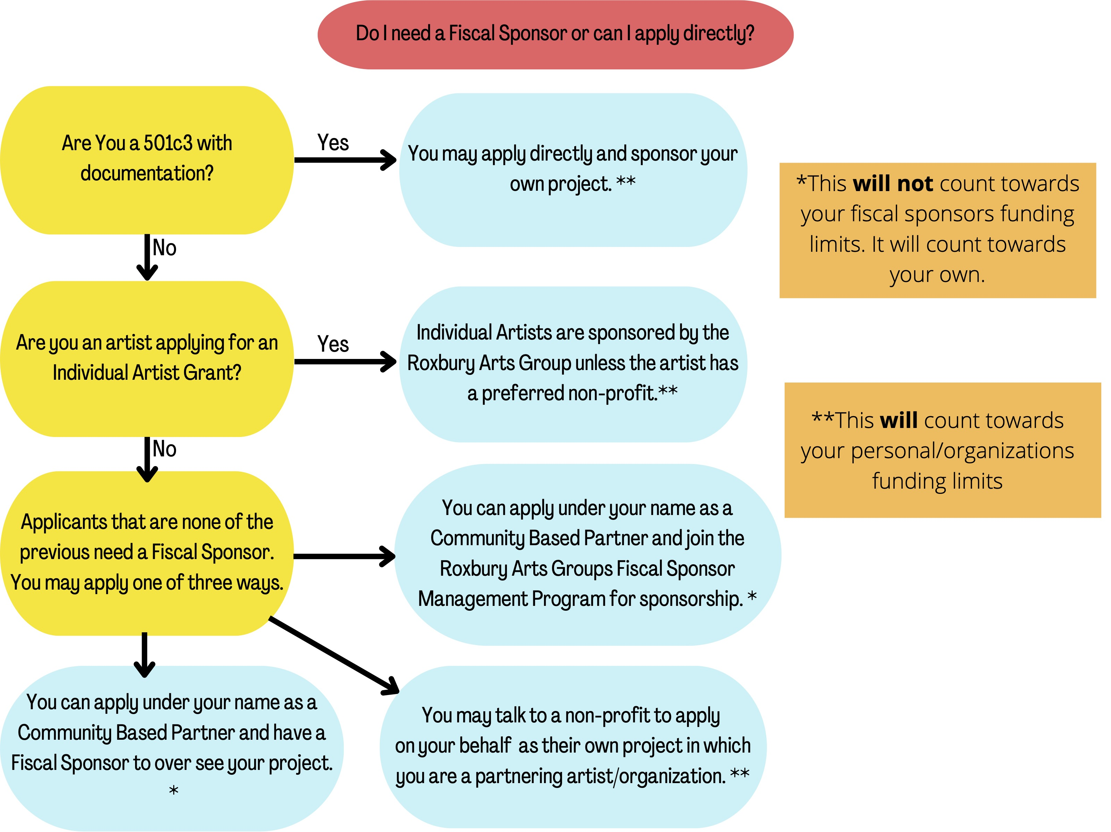

* 1. **What is a Fiscal Sponsor?**

An individual artist or collective that has no 501c3 status may apply for a Delaware County Arts Grant through an applicant chosen fiscal sponsor. Organizations that are non-profits may apply directly and serve as their own Fiscal Sponsor. The entity serving as the fiscal sponsor must meet the same eligibility requirements as an applicant organization listed above *(See Eligibility 3.)* Awards are sent to the address of the Fiscal Sponsor on the W9 provided.

* The fiscal sponsor must be based in Delaware County; however, the sponsored applicant is not required to reside in that county.
* A direct Delaware County Arts Grant applicant may also serve as a fiscal sponsor. Serving as a fiscal sponsor, those requests do not count towards the three-request limit or $5000 maximum.
* The sponsored applicant is limited to three requests in any combination of categories totaling no more than $5000.
* Direct NYSCA applicants may not serve as a fiscal sponsor for a Delaware County Arts Grant applicant.
* A letter of Agreement is required detailing roles, responsibilities and commitment from the Fiscal Sponsor. The Letter must also name the applicant and give permission for them to apply, this includes staff members applying directly on behalf of non-profits and applicants applying under Fiscal Sponsor guidance.
* Fiscal sponsors will handle receiving the award from the Roxbury Arts Group. Further finance arrangements should be made between the fiscal sponsor and the applicant. This should be laid out in the Letter of Agreement between parties.
* Fiscal sponsors are responsible for all IRS required reporting including the creation and distribution of 1099 forms where applicable.
* Fiscal sponsors are responsible for all grant reporting requirements including applications, change of scopes and final reports.
* Fiscal Sponsors are expected to assist applicants in the completion of their application, budget, projects and remain aware of project changes. Fiscal Sponsors may ask their applicants to attend technical assistance programs hosted by the Roxbury Arts Group under the Fiscal Sponsorship Management Program or provide their own technical assistance.
* Fiscal Sponsors are expected to read the Fiscal Sponsor Handbook provided to them.
* Must be based in Delaware County.
* Submit a list of their board of directors, mission statement, and a financial statement.
  1. **What is a Community Based Partner?**

Organizations or Individual Artists can apply directly for SCR funds as Community Based Partners in the Community Arts Category or the Creative Learning Grant. Community Based Partners are enrolled in the Roxbury Arts Group Fiscal Sponsorship Program. Awards in these cases are sent to the Community Based Partner address detailed on the W9 provided. Organizations must detail and select a single member who will receive funds and must include this individuals Social Security in the W9 provided in their application. Awards CANNOT be paid to businesses.

* The Community Partner must be based in Delaware County.
* You are limited to three requests in any combination of categories totaling no more than $5000, Community Based Partner applicants count towards this funding limit.
* Direct NYSCA applicants may not apply for the Delaware County Arts Grant applicant.
* Community Based Partners will handle receiving their own award from the Roxbury Arts Group.
* Community Based Partners should manage all IRS required reporting including the creation and distribution of 1099 or W9 forms where applicable.
* Community Based Partners are responsible for all grant reporting requirements including applications, change of scopes and final reports.
* A letter from the Community Based Organization acknowledging the applicant as part of the organization is required and should be on the organizations Letter Head and be signed by an organizations board member.
* Must be based in Delaware County.

Community Based Partners are Fiscal Sponsorship Management Program of the Roxbury Arts Group and should arrange to have a meeting with the Fiscal Sponsorship Manager prior to submitting and application. The Roxbury Arts Group provides assistance to its applicants to create budget, applications and reports as well as a number of technical assistance workshops and development and growth opportunities to its applicants under this program. Applicants are encourage and expected to attend these workshops.

* 1. **Individual Artists and Fiscal Sponsorship**

Typically artists applying under the Individual Artist category are Fiscally Sponsored by the Roxbury Arts Group in the Fiscal Sponsor Management Program. However if artists have a non-profit they would prefer to work they are allowed to do so. Artists looking for Fiscal Sponsorship for the Roxbury Arts Group must arrange for a meet and greet to discuss their project and the roles and responsibilities expected. A Letter of Commitment will be drafted between the artists and the arts center to reflect this and should be attached to your application. The Roxbury Arts Group provides assistance to its applicants to create budget, applications and reports as well as a number of technical assistance workshops and development and growth opportunities to its applicants under this program. Applicants are encourage and expected to attend these workshops.

The Roxbury Arts Group can introduce artists and organizations to help facilitate collaborations.

### COVID 19 New Guidelines 6.

**a. COVID 19 Guideline Changes**

The Delaware County Arts Grant has had a number of changes to help artists and organizations continue to offer quality arts programs and projects to the public of Delaware County. These changes are listed below.

* Online Audience: Organizations can create online content or workshops. In your application you should estimate the number of views, clicks, audience members, etc your online content may create. It would be beneficial to record the number of clicks on links or views on videos for your final report.
* Materials: Expenses that include consumable equipment, such as memory sticks, lighting gels, sheet music, lamps etc are all now permissible. No one purchased item can cost more than $1,000.
* Permanent Equipment: Permanent equipment required to execute projects, such as cameras or lighting equipment, are allowed to be purchased with Delaware County Arts Grant funds. No one item can cost more than $1000 and cannot be a capital improvement. A letter stating who will hold ownership of said equipment and where the equipment will reside after the completion of the project is required with your application and should be signed by the board president of the non-profit fiscal sponsor, if applicable.
* Software and Subscription Services: The Delaware County Arts Grant will allow funding for the purchases of software and subscription services that are required for projects. This could include paid subscription plans for Zoom, for example. No one purchased item can cost more than $1,000.
* Direct administrative expenses and/or planning and preparation expenses for a proposed event including training on software and subscriptions, can be included in the project cost.

### Information Sessions 7.

All applicants, even those that have received funding in the past, **MUST** meet either in person, digitally or by phone with Roxbury Arts Group staff to discuss your project. An in-depth review of the guidelines and application will be presented at a series of Grant Information Sessions. Applicants who are unable to attend a meeting may request a meeting with the Grants & Community Coordinator. The individual responsible for completing the grant application is encouraged to attend.

Grant Information Sessions have been scheduled at the following dates and times:

**In Person Sessions:**

Wednesday October 19, 2022 William B Ogden Free Library

5:30 pm 42 Gardiner Pl, Walton, NY 13856

Friday November 4, 2022 Roxbury Arts Group

Noon 5025 Vega Mountain Road, Roxbury, NY 12474

(607) 326-7908

**Online Sessions:**

Thursday September 22, 2022 Zoom

5:30pm

Friday October 7, 2022 Zoom

Noon

Saturday October 29, 2022 Zoom

5:30 pm Individual Artist Session

Tuesday November 1, 2022 Zoom

Noon

### How to Apply 8.

**a. Application Deadline**

**Applications must be submitted via Submittable (an online program) to the Roxbury Arts Group no later than 4 pm ON Thursday, November 17, 2022.** Early submissions are encouraged. Applications received after the deadline will not be accepted. Incomplete, handwritten or ineligible applications will not be considered.

**b. Where to get an application**

A link to the Submittable Application is available at the Roxbury Arts Group website at [www.roxburyartsgroup.org](http://www.roxburyartsgroup.org). Guidelines and a link to the applications can also be emailed to you upon request.

**c. Drafts Deadline**

If you wish to have the Roxbury Arts Group staff review a draft of your request, you may schedule a meeting either in person or by phone. Reviewing an applicant’s draft proposal is for the purpose of providing technical assistance and does not guarantee that it will receive funding. Drafts must be submitted prior to meeting with Roxbury Arts Group staff. The deadline for submitting a draft for review is three weeks prior to the application deadline **Thursday, October 28 2022.**

**d. Additional Materials and Work Samples Required**

Yes.

**Required Documents:**

Your application will not be accepted without the required documents. The list below details all required materials over all applications. The chart below shows which are required for your applications situation, documents with a * are needed for your application:

* A W-9 signed and dated in the current year. If you are applying through or for a non-profit this should include their EIN number. If you are applying as an Individual Artist, it will include your personal Social Security Number.
* Proof of Residency
* Proof of non-profit status.
* Fiscal Sponsor Agreement between Non-profit fiscal sponsor (including sponsorship by the Roxbury Arts Group) and Artist detailing roles and responsibilities between parties. The Fiscal Sponsor Agreement must outline in detail the partner(s) support of the project (monetarily and otherwise) and anticipated roles and responsibilities for each partner involved. The partnership letter should be on the partner(s) letterhead and signed by the director of the partner organization.
* List of Non-profit Board members.
* Non-profit Mission Statement.
* Most recent complete Financial Report of Non-profit.
* If Permanent Equipment is purchased a letter detailing who will be responsible for the equipment after the project has ended. This should be signed by the Non-Profit board president.
* Budget.
* A letter from the Community Based Non-profit Organization acknowledging the applicant as part of the organization and should be on the organizations Letter Head and be signed by an organization’s board member.
* A Letter of commitment from the partner school to be eligible for funding. The letter of commitment must outline in detail the partner(s) support of the project (monetarily and otherwise) and anticipated roles and responsibilities for each partner involved. The partnership letter should be on the partner(s) letterhead and signed by the principal of the partner school and the director of the partner organization.

|  |  |  |
| --- | --- | --- |
| IA (Individual Artist) | CA (Community Arts) | CL (Creative Learning) |

|  |  |  |  |  |  |  |
| --- | --- | --- | --- | --- | --- | --- |
|  | Artist's Applying for IA Grants With RAG Fiscal Sponsorship | Fiscally Sponsored CA Grants | Fiscally Sponsored CL Outside of Schools | Community Based Non Profits Applying for CA/ CL Outside of Schools | Community Based Non-profits Partners CL In-schools | Artists Applying for CL In-side Schools |
| W9 | * | * | * | * | * | * |
| Proof of Residency | * |  |  |  |  | * |
| Fiscal Sponsor Agreement | * | * | * |  | * |  |
| Letter of Commitment from School |  |  | * | * | * | * |
| List of Board Members |  | * | * | * | * |  |
| Non-Profit Mission Statement |  | * | * | * | * |  |
| Financial Report of Non-Profit |  | * | * | * | * |  |
| Letter of Permanent Equipment |  | * | * | * | * |  |
| Budget | * | * | * | * | * | * |
| Letter Acknowledging Applicant as a member of staff or has permission to apply |  |  |  | * | * |  |

**Optional but highly recommended:**

* Work samples.
* Artist Bio’s.
* Artist Statements.
* Links to video clips of performances.
* Previous promotional materials if a recurring project.
* Feedback from Audience/Participants of annual projects.
* Photography, Articles, videos etc of previous events.

**e. Other documentation during and After Projects**

If a directly funded NYSCA organization is hosting/handling a Delaware County Arts Grant projects Box office, see NYSCA site 4. for required reporting that should be made available on request of the Roxbury Arts Group at the completion of the project.

On completion of all Delaware County Arts Grant projects a final report should be created and signed by the Organization/Fiscal Sponsor or in collaboration with the Fiscal Sponsor and Artists involved and provided to the Roxbury Arts Group within 30 days of the final event date or before December 31st 2023.

Should changes be made to projects after funding has been awarded, a Change of Scope should be completed and returned to the Roxbury Arts Group as soon as possible. This includes changes made if partial funding is awarded.

**f. Matching Funds.**

Your project budget must demonstrate that a minimum of **10%** of the proposed project income comes from other funding sources. This can include planned in-kind contributions (non-monetary), cash contributions, cash income, or a combination of both. In-kind contributions must be noted in the project income section of your budget including the type of donation in the explanation, if your donation is not monetary in the In-kind Value/Amount column include the cost of the donation if you were to pay for it.

### Decision Making 9.

**a. Grant Decisions**

Applications are reviewed for eligibility, completeness, and accuracy by Roxbury Arts Group staff. It is your responsibility to submit a complete and accurate application. As part of the review process, Roxbury Arts Group staff may contact you by telephone or e-mail to clarify and review information.

A panel of artists, arts administrators, community leaders, and community members approved by the Delaware County Arts Grant Advisory Panel and appointed by the Roxbury Arts Group Board of Directors, evaluates each application and recommends a level of funding based on the evaluation criteria, the funding priorities and the grant guidelines. Upon request, Panelists will be furnished with final reports as well as audit information, prior panel comments and correspondence when considering organizations/individuals who have applied or been funded in prior years. The Panel's recommendations are reviewed by the Roxbury Arts Group’s Board of Directors, which has the final authority for all decisions. The Roxbury Arts Group staff has no vote in the decisions made.

If your community member would make a good panel member and you would like to nominate them for consideration on future panels, please go to roxburyartsgroup.org and go to the Delaware County Arts Grant under the opportunities tab to place a nomination.

**b. Panel Criteria**

Awards are based on a competitive review process. Each application is reviewed on the basis of its own merits and against others in the application pool. The panel will make funding recommendations based primarily on the following criteria:

* The artistic merit and quality of proposed project is priority over all panel considerations.
* Community benefit, service to a broad, unique or under-served constituency - demonstrated need for the project (community support and interest in the project)
* Appropriate budget for the project
* Clarity of goals and demonstrated ability to achieve them
* Adherence to the grant guidelines and funding priorities
* Clearly defined plan for the implementation and management of the program

For funding priorities see Types of Grants 2. d. Funding Priorities for 2023 e. Low Priority Projects

### Successful Applicants 10.

**a. Award Notification**

The Roxbury Arts Group notifies all applicants, by email, regarding the status of their application after Board approval. This usually occurs by the end of January and contracts will be mailed to awarded artists/organizations shortly thereafter. Projects sponsored by a Fiscal Sponsor will have checks mailed to the sponsoring organization, otherwise checks will be mailed out to Individual Artists or funded organizations. Funds will only be disbursed after all documentation is accounted for including a signed contract. Checks will only be mailed out to Delaware County addresses detailed on the supplied W-9 NO EXCEPTIONS.

**b. Grantee Responsibilities**

* Sign and adhere to the terms of a Project Contract and a Publicity Agreement which includes crediting both the Roxbury Arts Group and NYSCA for funding on all materials according to language used in the project contract as well as including the Roxbury Arts Group logo (not NYSCA’s) on all printed materials relative to your funded project;
* Attend and participate in the Delaware County Arts Grant awards ceremony;
* File reports as identified in the project contract;
* Provide copies of publications and promotional materials related to the funded project;
* Provide Roxbury Arts Group with an advance schedule of funded events;
* Provide four complimentary tickets for Roxbury Arts Group auditors; and
* Notify the Roxbury Arts Group in a timely fashion, of any changes to your project including dates, times and places where events are to be held.

### Appeals 11.

An appeals process is in place for applicants who are denied funding and can demonstrate that information was withheld and/or misrepresented, and/or that an improper procedure occurred. ***Dissatisfaction of the Panel’s decision or funding level is not grounds for appeal***. Applicants denied funding will be furnished with the entire Appeals Process and Procedures when notified in writing of the Board's determination.

### Application Deadline 12.

**Applications must be submitted via the Roxbury Arts Group website under the Opportunities tab by**

**4 pm on Thursday, November 17, 2022.** Late or incomplete applications will not be accepted or reviewed.

**QUESTIONS:**

**Contact Samantha Nick, Grants & Community Coordinator, at 607.326.7908 or by email at community@roxburyartsgroup.org.**