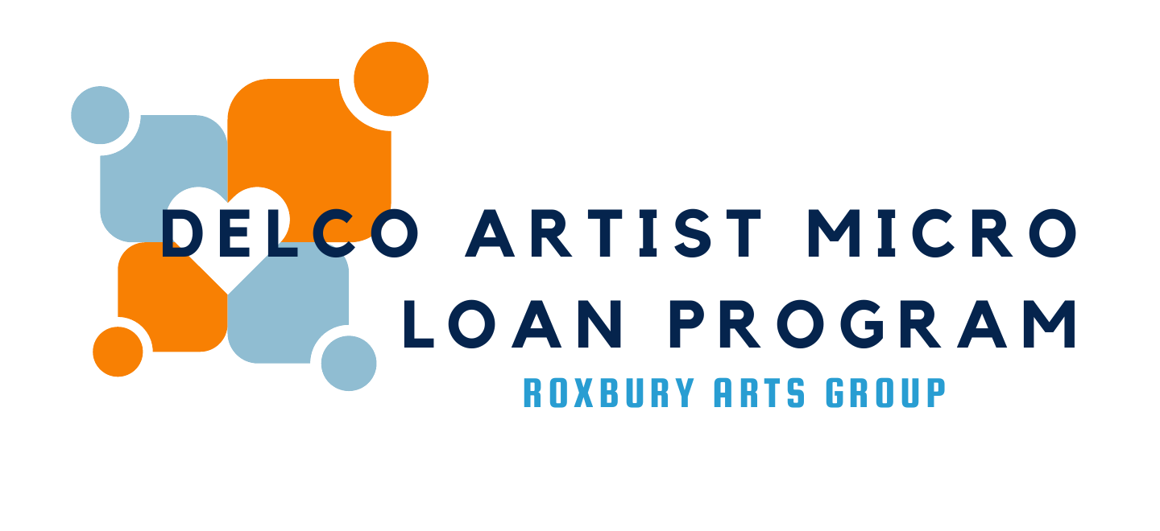

Delaware County Artist Micro Loan Program Guidelines

Mission Statement

To provide funds for artists in Delaware County that may provide access to tools and opportunities for professional development and career advancement.

Goals
The goals of the Delaware County Artist Micro Loan Program, are as follows:
- To create opportunities for artists to advance in their career.
- To assist an artist to continue to create while dealing with unplanned expenses.
- To develop a financial environment that is more hospitable for Delaware County artists.
- To provide an accessible loan opportunity for workers in the creative community.
For the purpose of this program, the term “artist” shall mean any individual working and generating income in a recognized artistic discipline either full or part time. Or an individual looking for financial assistance for a specific purchase to become a working artist.

Applicants must acknowledge defaulting on their loans will result in the collapse of the program and no further opportunities for assistance.

Use of Funds
The following is a partial list of the types of uses, which are eligible for loans:
- Materials
- Professional development workshops or travel costs relating to them
- Publishing costs
- Exhibition costs (such as framing work or materials to create. Hospitality costs such as food and drink are not funded)
- New or upgraded musical instruments
- Studio improvements
- Funds that assist an artist to continue to create during unexpected financial burdens.
This list is only as an example. If you’re unsure if your application fits our guidelines call the Roxbury Arts Group at 607-326-7908 or email Samantha Nick, Grants and Community Coordinator at community@roxburyartsgroup.org.

Eligible Applicants & Documents Required
All artists in Delaware County are eligible. Applicants must provide:
- A W-9 signed and dated in the current year.
- Proof of full or part time residency consisting of an image of a driver’s license showing a Delaware County address or two bills dated in the last 12 months showing name and Delaware County address.
- Budget

Where applicable you may also be asked to provide:
- If you are applying for a purchase of permanent equipment with a single item, evidence of the cost and purchase location such as a web link, screenshot or quote of where you plan to make the purchase is required.
- For home or studio improvements requiring the use of contractors, applicants should submit a quote with their application. Applicants should use licensed and insured contractors and renovations should meet all local building code requirements.

Loan Criteria and Priorities
Each loan will be reviewed on a case-by-case basis by a panel of artists and community peers. The intent of the program is to help further an artists creative career or provide access to tools, professional development or financial assistance to continue to create during unexpected expenditures.
Specific loan review criteria and priorities are as follows:
- Artists must be located in Delaware County
- Applications that demonstrate career development
- Applications that provide access to tools or materials
- Funds that assist an artist to continue to create during unexpected financial burdens.

Loan Terms and Requirements

Maximum Loan: $1500 Minimum Loan: $250.

Loan Term: The schedule of payments will be determined by the applicant and the Roxbury Arts Group at a rate that is agreeable for all parties. Loans will have flexible terms dependent upon the type of project financed and the needs of the applicant. No one loan payment program shall last longer than one year.

Interest Rate: Loans will have zero interest for the original agreed Loan Terms of one year. If the applicant is deemed delinquent on their loan, compound interest at a rate of 3% monthly will begin. Compound interest, being interest that accrues on both the initial principle and accumulated interest from previous periods. Failure to make payment on the loan will result in the ending of the Delaware County Artist Micro Loan Program.

Code Requirements: Applicants must meet all code requirements either at loan closing or upon project completion.

Career Advancement: Preference will be given to applicants that demonstrate clear career advancement.

Rehabilitation Work: For projects involving rehabilitation, applicants must obtain bids and provide their chosen quote. Contractors should be licensed and insured as applicable. For projects should meet all code requirements and as needed State Historic Preservation Office regulations.

Refinancing Existing Debt: No funds may be used to refinance existing debt. Funds that assist an artist to continue to create during unexpected financial burdens are permitted but should have a clear budget of costs.

Confidentiality: Assistance provided will be subject to public disclosure, but all financial information will be kept confidential.

Reporting: Applicants will be expected to provide proof of purchase and progress report within 30 days of the last payment date of the agreed loan terms. Applicants that fail to meet their agreed loan terms may not be permitted to access other opportunities funded by the Roxbury Arts Group or may have the actions reported for consideration for opportunities not funded by the Roxbury Arts Group such as the Delaware County Arts Grant.

Review Committee
The review committee shall include representatives of the Delaware County community and members of the Roxbury Arts Group Board of Directors.

Approval Process
The Roxbury Arts Group is the Manager and Administrator of the Delaware County Artist Micro Loan and is responsible for providing support and technical assistance to artists. The Roxbury Arts Group will assist in program delivery and oversee implementation of the program. If applicants fail to meet the agreements of their loan, the program will collapse and this opportunity will end for Delaware County artists.
The Grants and Community Coordinator will review the application for completeness and will determine the suitability and appropriateness of the project given the loan review criteria. The Review Committee will then review the application and make funding recommendations on loans to the Executive Director shall make final approval for the loan amount and negotiate the loan terms with successful applicants.
The Roxbury Arts Group will collect repayment of its loan proceeds and distribute the funds to the appropriate accounts.

Post Approval Requirements
All loan recipients are required to report their expenditures by providing proof of payments through receipts and copies of checks or credit card statement within 30 days of the last payment date or of zero balance. Quotes/invoices are not considered proof or payment. Should these not be provided, recipients may be considered in default of loan obligations and legal action could commence.

